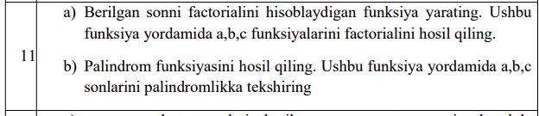
1-Jadval.11-misol.a

#include <iostream>
#include <cmath>
using namespace std;

double HandMadeFactorial(double a) {
//Gamma usuli bilan hisoblash
double res = sqrt(2*M_PI*a)*pow(a/M_E,a);
return res;
}

double BuiltInFactorial(double a) {
return tgamma(a + 1);
}

int SimpleFactorial(int a) {
if(a<= 1) return 1;
return a * SimpleFactorial(a - 1);
}

int main() {
double a,b,c;
cin >> a >> b >> c;
cout << HandMadeFactorial(a)<<endl;
cout << BuiltInFactorial(b)<<endl;
cout << SimpleFactorial(c)<<endl;

return 0;
}

Ibrohimov Abdulloh

1-Jadval.11-misol.b

#include <iostream>
using namespace std;

bool isPalindrom(string s) {
int len = s.length();
for(int i = 0;i<len/2;i++) {
if(s[i] != s[len-i-1]) {
return false;
}
}
return true;
}

int main() {
string a,b,c;
cin >> a >> b >> c;
cout << (isPalindrom(a) ? "Ha" : "Yo'q") << endl;
cout << (isPalindrom(b) ? "Ha" : "Yo'q") << endl;
cout << (isPalindrom(c) ? "Ha" : "Yo'q") << endl;

return 0;
}

Ibrohimov Abdulloh

2-Jadval.11-misol
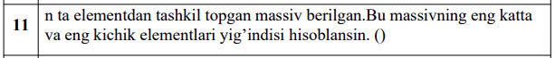
#include <iostream>
using namespace std;

int main() {
int n,a[1000];
cin >> n;
for (int i = 0;i<n;i++) {
cin >> a[i];
}

int min=a[0];
int max=a[0];
for(int i = 1;i<n;i++) {
if(a[i] < min) min = a[i];
if(a[i] > max) max = a[i];
}

cout<<min+max;

return 0;
}

Ibrohimov Abdulloh

3-Jadval.11-misol

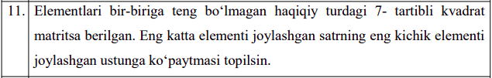
#include <iostream>
using namespace std;

int main() {
int q,a[1000][1000];
cout << "Kvadrat matritsa uchun qatorlar va ustunlar soni: ";
cin >> q;
for(int i = 0;i<q;i++) {
for(int j = 0;j<q;j++) {
cin >> a[i][j];
}
}

int maxQ = a[0][0];
int minU = a[0][0];
int numQ=0,numU=0;
for(int i = 0;i<q;i++) {
for(int j = 0;j<q;j++) {
if(a[i][j] > maxQ) {maxQ = a[i][j];numQ = i;}
if(a[i][j] < minU) {minU = a[i][j];numU = j;}
}
}
int res[1000];
for(int i = 0;i<q;i++) {
res[i] = a[numQ][i] * a[i][numU];
}

for(int i = 0;i<q;i++) {
cout << res[i] << " ";
}
return 0;
}
Ibrohimov Abdulloh

